Position Description
Sierra Nevada AmeriCorps Partnership

Host Site – Location
Position Title: | Type:
Southern Sierra Reforestation Technician | - Full Term  □ Half Term

Organizational Background:
American Forests is a national non-profit organization committed to creating healthy and resilient forests from cities to wilderness, that deliver essential benefits for climate, people, water and wildlife. We advance our mission through forestry innovation, place-based partnerships to plant and restore forests, and movement building. We envision a world in which the significant environmental, societal and economic benefits of forests are fully realized and equitably available to all people. Established in 1875, American Forests is the oldest national non-profit conservation organization in the U.S. working to restore urban forests and forested landscapes. To learn more, visit https://www.americanforests.org/.

American Forests is proud to be a diverse, equitable, inclusive and accessible (DEIA) workplace. These are our shared values. We welcome individuals who bring a variety of backgrounds and experiences to be a part of our team to help make a difference individually and collectively as we work toward achieving our mission. We are committed to fostering an environment that is welcoming and respectful and to providing opportunities for advancement and professional growth for every team member.

We hope you find your future with us.

Number of Technician Positions at this Site: 1 SNAP Technician (and 1 Sierra Corps Forestry Fellow)

Site Supervisor’s Name(s) and Title(s): Britta Dyer (she/hers), Senior Director of California and Pacific Islands

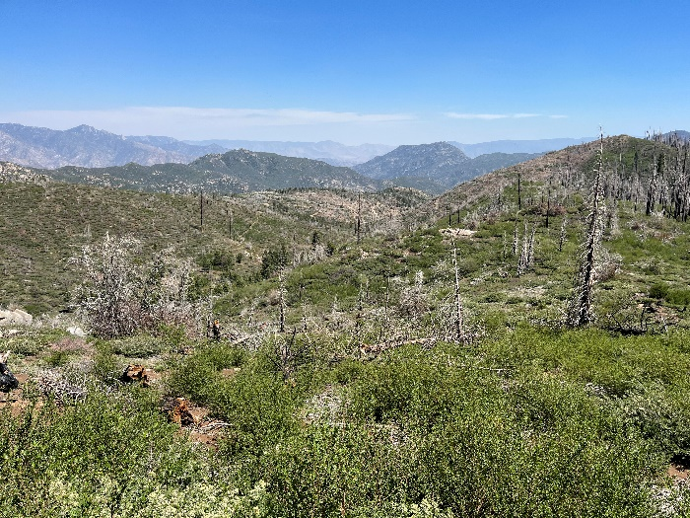
Position Description:
The Southern portion of the Sierra Nevada Mountains has experienced devastating impacts from a rapidly changing climate, including numerous mega-fires that have increased the likelihood of a full ecosystem conversion across the landscape. American Forests is currently addressing these impacts through the Sequoia Wildfire Reforestation and Recovery Project (SQWRR), which is a landscape-scale effort to restore and reforest 2,600 acres within priority areas of five wildfire footprints across the region. This project is being implemented in partnership with the Sequoia National Forest, Mountain Home State Demonstration Forest, and Tule River Indian Tribe.

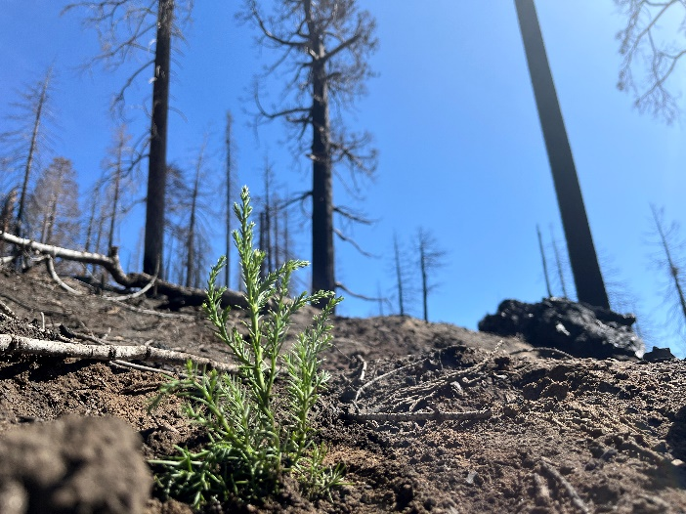
The Southern Sierra Reforestation Technician will assist every step of reforestation through on-the-ground implementation of SQWRR. This includes, but is not limited to, laying out units and contract inspections for pre-planting fuels reduction, direct on-the-ground planting, and post-planting release treatments; as well as monitoring and surveying after planting. This position will support cone collection efforts through cone surveying and seed collection contract inspection on the Sequoia National Forest. They will also lead a field surveying and monitoring project to track natural regeneration and assist with analysis and documentation to plan for future reforestation treatments. Over the winter months, the Technician may have the opportunity to assist the Sequoia National Forest with public education and outreach efforts if they are interested. Coordinating closely with a SierraCorps Fellow to complete these activities, this position will also work alongside staff from American Forests, Sequoia National Forest, occasionally, Mountain Home State Demonstration Forest, and other partner organizations as appropriate.

This position is a great opportunity to build your career in forestry and natural resources, directly implement an innovative post-fire recovery effort, and gain highly in-demand skills including contract management, seed collection, and reforestation project planning. American Forests has seen rapid growth over recent years, and expects our portfolio of projects in the Southern Sierra to continue to expand. While we cannot guarantee employment at the end of the service term, the Technician will gain skills and experience valuable to American Forests in developing and leading innovative reforestation and restoration projects in the region.

Site-Specific Training Provided:
The Technician will develop a professional development plan to identify specific goals that meet both project objectives and their own personal goals. American Forests will provide a $700 professional development stipend per Technician to support these goals. This can be used to pay certification costs, registration fees, mileage and/or lodging for approved professional development opportunities that both the Site Supervisor and Technician deem appropriate.

Some examples of trainings that will be available to the Technician: Cone Collection and Contracting Training, R5 Reforestation for Beginners, USFS Qualified Cruiser School, data collection and monitoring protocols, GIS, contract administration, and project management.

Things to Note:
This position will be based in the Southern Sierra and will require travel to a variety of field sites across the region. Due to the landscape-scale nature of the SQWRR project, drive times will often be lengthy and there will be multiple projects where it is most efficient for the Technician to camp out on Forest Service land for multiple nights. The Southern Sierra Reforestation Technician will be responsible for finding housing near Porterville or Springville. American Forests is providing the Technician with a $300 per month housing stipend to offset the cost of living in the area, and is willing to assist to a reasonable degree in their search to secure housing.

A central work location, either in Porterville or Springville, at Forest Service offices may be made available to the SNAP Technician, but they may also be granted permission to conduct office work from home/remotely when appropriate. A work vehicle will be available to the SNAP Technician and SierraCorps Technician to share, and will be kept at the central work location.

Most work will be performed in a field setting, which includes: 1) Varied terrains, dense vegetation (with possible exposure to poison oak, ticks, and mosquitos), and hot, cold, and wet conditions; 2) Severely burned landscapes with standing dead trees and little to no shade; and 3) Most sites are will be accessible within a short distance from a road. Some office work, including data entry, emailing, virtual meetings, tracking and report writing, will also be required.

REQUIRED QUALIFICATIONS:
- Bachelor’s degree in Forestry, Environmental Science, or related field OR at least 2 years of forestry vocational training.
- Ability to work independently, self-manage and communicate to maintain productivity and American Forests / Forest Service expectations.
- Ability to think creatively, problem solve, and a willingness to find innovative solutions.
- Strong desire to work in a forest health related career, ideally in the Sierra.
- Ability to work with diverse partners and stakeholders, and facilitate productive decision-making.
- Ability to commit to the full fellowship term.

DESIRED QUALIFICATIONS:
- Previous job experience with natural resource management and assessment, conservation planning, project management, and/or environmental analysis and research.
- Experience laying out treatment units based on environmental conditions and a given prescription, navigating using a topographic map and flagging boundaries.
- Experience using GIS.
- Ability to use Avenza.
- Experience safely operating a 4WD vehicle on unpaved forest roads.
- Experience with leave-no-trace vehicle-based camping.
- Basic knowledge of ecology of Sierra mixed-conifer forests.
- First Aid, Wilderness First Aid or Wilderness First Responder certification.

PHYSICAL REQUIREMENTS
The majority of activities will be field forestry, which includes the following:
- Ability to lift 40 lbs. and carry the load in a pack or vest.
- Repetitive tasks with few breaks.
- Work in adverse weather conditions including but not limited to high heat, rain, snow, smoke, dust, and cold temperatures (within reason).
- Walk, hike, or stand for extended periods of time with others and alone in steep, rugged, brushy, and/or remote terrain under adverse weather conditions.
- Ability to drive lengthy distances to a project work site.

WORK HOURS
8-hour days | 10-hour days | 10+ hour days
25% | 65% | 10%
Housing Offered through Site:  No | Vehicle provided for Placement Site work:  Yes
TYPE OF WORK
Field Work  (field surveys, planting, invasive pulls, maintenance, etc.) | Office Work  (lab analysis, data entry, GIS, writing, etc.) | Travel  (travel to field work and project Sites) |  | Restoration and Assessment (water quality monitoring, habitat restoration, fish surveys, etc.) |  | Education  (teaching, citizen science, etc.) | Volunteer Recruitment & Management | Technician Training  (Site-specific training, conferences, and development opportunities) | Other  (gear and equipment maintenance, outreach, etc.)
25% | 20% | 15% |  | 20% |  | 0% | 5% | 10% | 5%

