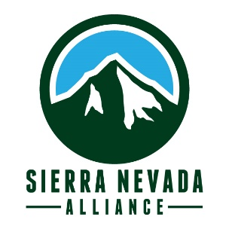

Position Description
Sierra Corps Forestry Fellowship
Position Title:
Host Site:
Site Supervisor:

Work Commitment: Sierra Corps Fellows are passionate and committed to the mission of the Sierra Nevada Alliance and Sierra Corps. Fellows make a full-time commitment to serve a nonprofit organization or public agency in the Sierra Nevada. Positions begin in January or February 2021. Time Commitment: 10-12 months, 1700 hours total.

Position Location: Town, County

Organization Description:

Position Description:

Required Qualifications: (edit as you see fit- these are just suggestions)
- Bachelor’s degree in Forestry, Environmental Science, or other related field
- Knowledge of CEQA/NEPA regulations and documentation
- At least 1​​year of experience with natural resource management and assessment, post education
- Ability to work with diverse partners and stakeholders and facilitate productive decision making
- Ability to commit to full term of Fellowship position
Desired Qualifications: (edit as you see fit- these are just suggestions)
- 2 years combined experience in:
  - forest health monitoring and assessment
  - conservation planning
  - project management
  - environmental analysis and research
- Strong desire to work in a forest health related career, ideally in the Sierra
- Passion for conservation of the Sierra

Host Site Website:

